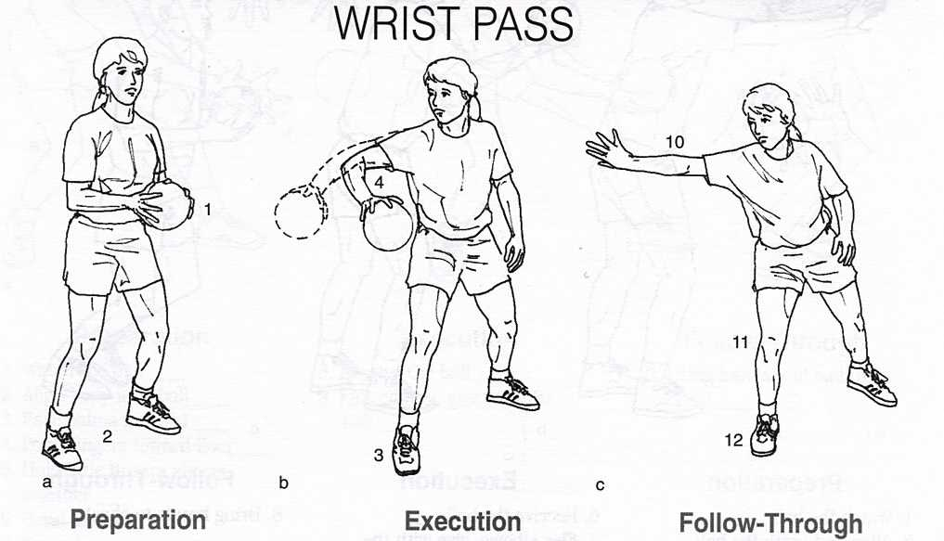

Handball

**Preparation**

_____1. Grip ball with two hands at waist

_____2. Place feet shoulder width apart

**Execution**

_____3. Step laterally toward target

_____4. Raise and point elbow toward target

_____5. Grip ball in passing hand

_____6. Transfer weight toward target

_____7. Extend elbow

_____8. Flip wrist

_____9. Push ball with thumb

**Follow-Through**

_____10. Extend and relax passing arm

_____11. Bend knee

_____12. Put weight on passing-side foot